Name – Akshat Bhargava

Roll no – 22563

DS – SL3

Prac 6

Code:

1. Import libraries, load and process ‘Iris.csv’ dataset.

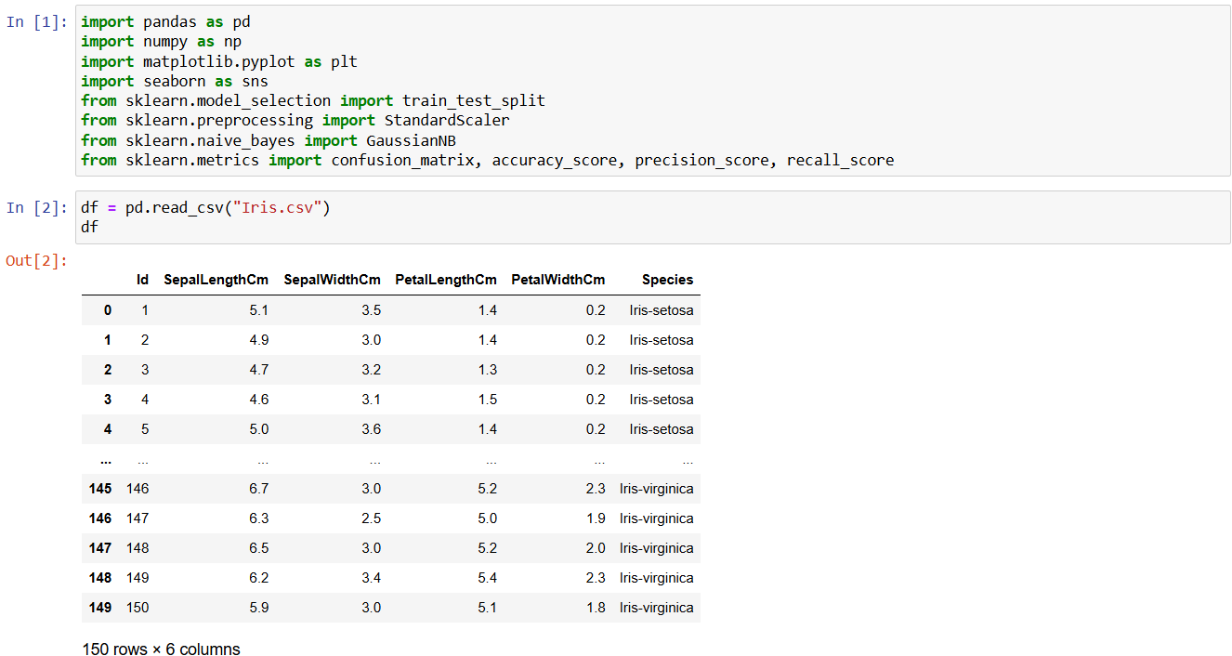

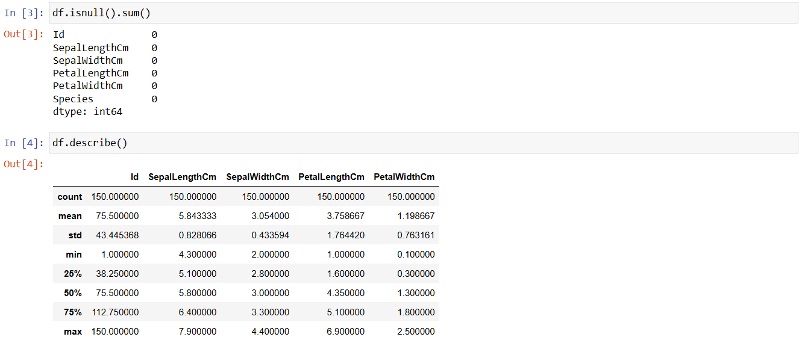

2. Implement Simple Naïve Bayes classification algorithm using Python/R on iris.csv dataset.

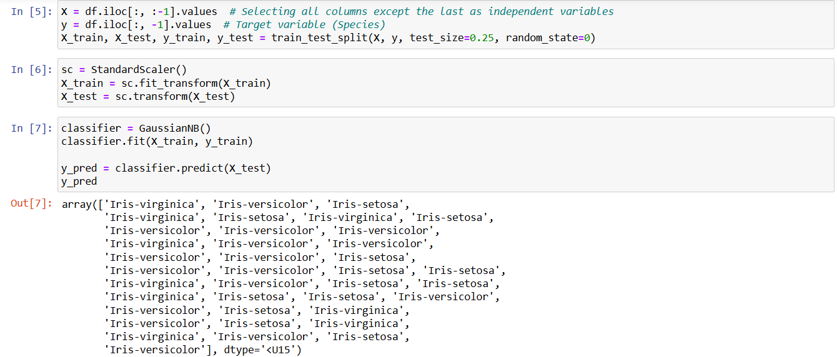

3. Compute Confusion matrix to find TP, FP, TN, FN, Accuracy, Error rate, Precision, Recall on the given dataset.

